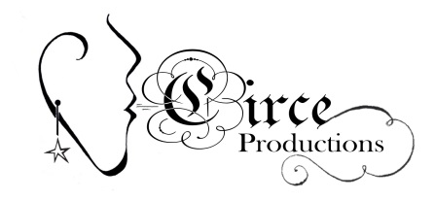
32nd Annual

Women in the Arts Festival
November 10-11, 2017

Artist/Vendor Registration (Please type or print legibly)
Registration Deadline: October 1, 2017

Contact Information
Your Name
Business Name
Address
Phone E-Mail

Are you an Emerging Artist? Yes No (if you mark “yes”, the Artists’ Market Coordinator will contact you directly).

Booth Information
Spaces are 5’ x 8’ for $40 and include 2 worker day passes; half spaces are 5’ x 4’ for $25 and include one worker day pass.

I’d Like to Reserve: | Circle your Response | Price | Total
Number of Full (5’x8’) Spaces: | 1 or 2 | X$40 | $
Table for Full Space: | 1 or 2 | X$8 | $
Number of Half (5’x4’) Spaces: | 1 | X$25 | $
Table for Half Space: | 1 | X $4 | $
 |  | Total Due: | $

Your Display
Please describe your booth and display furnishings (backdrop, display stands, etc.), including height, so that we can set up the best traffic flow and visibility for all craftswomen (be specific).

Returning artists, where would you like to be located?
- Social Hall (with Sistrum Café) | - Front Hallway | - Back Hallway (near fountain) | - Community Room | - Small Chapel | - No preference

Your Offerings
Please provide a description of the art/craft/products you create/sell (limit 100 words):

You must send at least one photo which is an accurate representation of your work. Email to msuwattenberg@gmail.com

Promotional Information
Do you want your business contact information to be listed on www.witafestival.com website?
YES NO

If you have a website, what is your address? Please also provide any other sites you use (pinterest, etsy, etc.) so we can connect our attendees to you in as many ways as possible!

Applications are due by October 1, 2017. See artist information document for details.

If you have any questions or would like the mailing address for your application, please contact Abby Wattenberg at 810.964.5319 or msuwattenberg@gmail.com

